Estimating and analysis of Avocado Sales Using Machine Learning
- Avocado - The avocado, a tree likely originating from southcentral Mexico, is classified as a member of the flowering plant family Lauraceae. The fruit of the plant, also called an avocado, is botanically a large berry containing a single large seed. Scientific name of Avacado is Persea americana.
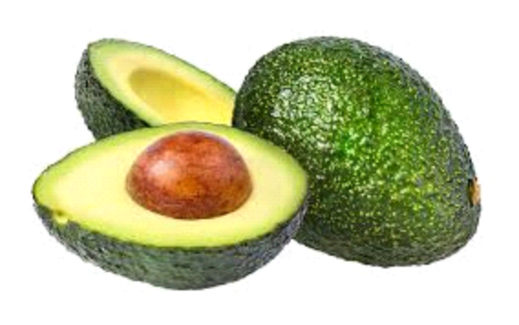
An avocado is a bright green fruit with a large pit and dark leathery skin. They’re also known as alligator pears or butter fruit. Avacado is becoming increasingly important in global agriculture.
- Introduction-
Avacado first appeared in Mexico thousands of years ago, but it was not until 1871 that it was brought to California, United States. By the 1950s, there are dozens of varieties like Fuerte, Hass avocado and etc., being sold in the markets of the country. At present, avocado consumption happens not only due to its flavor, but also due to its healthy contribution to people’s diets .
Currently, 85% of the avocados produced and sold in the world are of the Hass variety. This variety grows almost the whole year round and in different regions. Some of the leading producing countries are Mexico, United States, Chile, Australia, South Africa and Israel, with Mexico being the largest producer in the world. The United states is the leading country concerning imports, and has evolved towards a market of almost a million tons of avocados.
Avocado is consumed by people heavily in the United States. we have Avacado dataset which contains some features which are mentioned below -
Categorical: ‘region’,’type’
Date: ‘Date’
Numerical:
Unamed: 0 :
Total Volume : Total sales volume of avocados and bags
4046 : Total sales volume of Small/Medium Hass Avocado
4225 : Total sales volume of Large Hass Avocado
4770 : Total sales volume of Extra Large Hass Avocado
Total Bags: Total number of Bags sold
Small Bags: Total number of Small Bags sold
Large Bags: Total number of Large Bags sold
XLarge Bags: Total number of XLarge Bags sold
- Data Selection and Cleaning-
Data was prepared and cleaned in order to obtain an appropriate dataset, for understanding the fluctuation of the avocado market in the United States, based on total volume of avacado. For this purpose, we followed the Cross Industry Standard Process for Data cleaning process proposed exposes the data preparation tasks that were considered and precipitation in the 53 cities, during the same periods
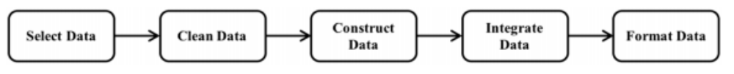
- Data Analysis -
1. Avacado dataset which we have ,has 18249 rows × 14 columns.
2. The Feature "Unnamed:0" is just a representation of the indexes, so it's useless to keep it, we'll remove it.
3. Searching for missing values: blank spaces, words such as “NaN” or “null” and special characters such as “*” or “?” were searched for, as to verify if there were any missing values in the datasets. In this dataset there is no missing values .
4. In Avacado dataset Date is object type so we convert it into datetime format.
5. By using lambda function we create new columns ,Month and Day.
6. In the avacado dataset there are two types of Avacado one is Conventional and other is Organic, almost both are in same quantity.
7. The dataset contains average prices and total volume sold for both organic and conventional avocados for 53 different markets (New York, Boise, St. Louis, etc.) that make up 8 larger regions (California, Great Lakes, Midsouth, Northeast, Plains, South Central, Southeast, and West).
8. In this dataset our target variable is averageprice.
- EDA-
figure 1(as bar graph) - Comparing average price of Avacado Region wise
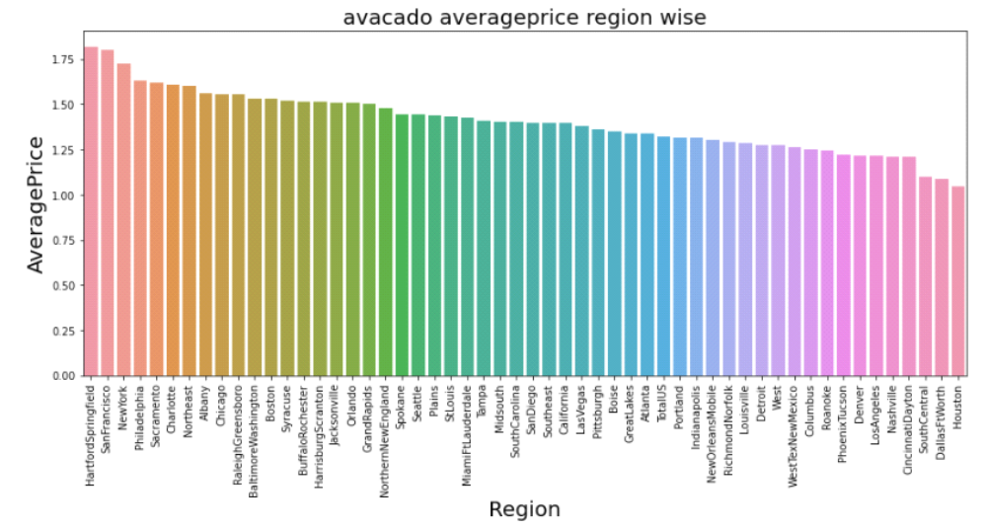
from above graph it is clear that there are many region where average price is high but here we are mentioning top 5 Region with stats of average price -
0 HartfordSpringfield 1.818639
1 SanFrancisco 1.804201
2 NewYork 1.727574
3 Philadelphia 1.632130
4 Sacramento 1.621568
figure 2(as bar graph) - Comparing Total volume of Avacado Region wise
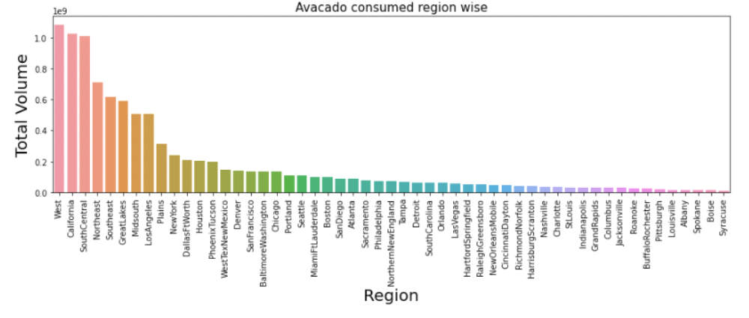
Above graph shows that there some region where Avacado is used heavily and some are where Avacado is used normaly. There are region like West, California and SouthCentral where Avacado is consumed heavily after that some region comes like Northeast, Southeast, GreatLakes, Midsouth and LosAngeles where Avacado is consumed mediumly.
figure 3(as line graph) - comparing of consuming Avacado region wise at the basis of size
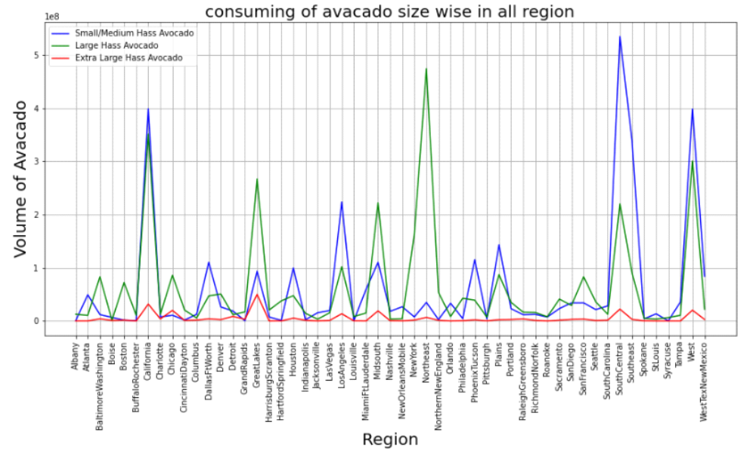
From above graph it is clear that mostly small/medium and Large Hass Avacado is consumed heavily and Extra large hass Avacado is less consumed.
Top 5 Region where small/medium Avacado is consumed heavily-
1. SouthCentral
2. California
3. West
4. LosAngeles
5. Plains
Top 6 Region where Large Avacado is consumed heavily-
1. Northeast
2. California
3. West
4. GreatLakes
5. Midsouth
6. SouthCentral
Region of GreatLakes where Extra Large Avacado is consumed so much comparing to other region.
figure 4(as line graph) - comparing of all size Avacado total volume sold out since 2015 to 2018
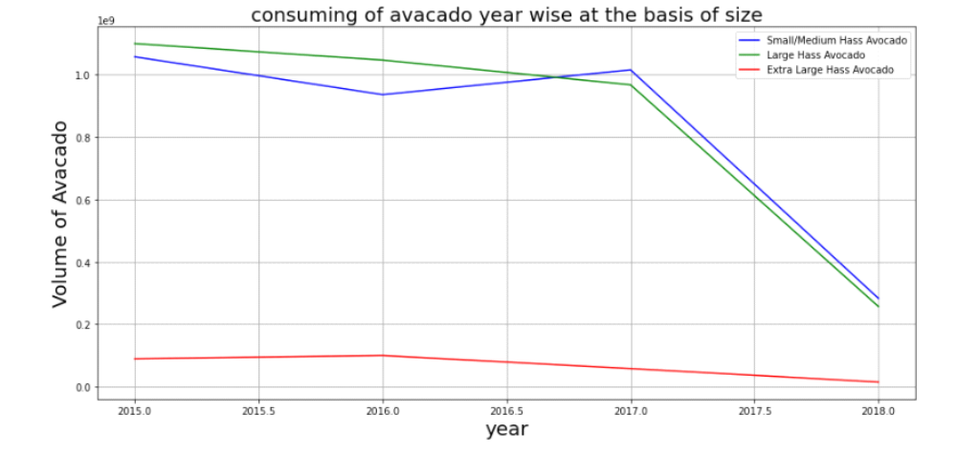
We can see clearly from above graph that there is slightly increasement in selling of Extra large avacado since 2015 to 2016 after that there is continuously decreasement till the end of 2018.
we notice that there is a continuously decreasement in selling of Large avacado till the end of 2018. Selling of small/medium avacado droped since 2015 to 2016 after that increasement was noticed in selling of small/medium avacado since 2016 to 2017. After ending of 2017 selling of small/medium avacado droped badly till the end of 2018.
figure 5(as line graph) - comparing of all size Avacado total volume sold out month wise
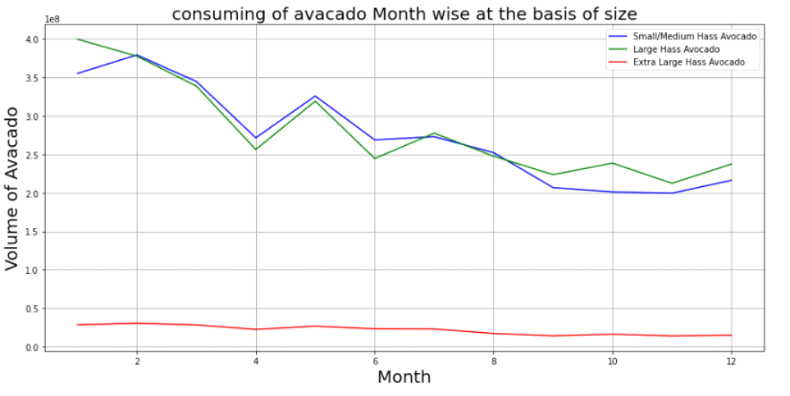
we can see in above graph that selling of small and large avacado is increasing and decreasing in every month, there is large increasement is noticed in month of 5 in selling of both avacado. Extra large avacado selling is droping down till the end of month 12.
figure 6(as line graph) - comparing Average price month wise
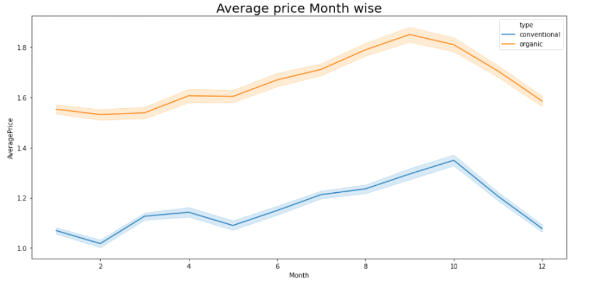
Above graph represent the average price of avacado in every month. It shows that conventional avacado average price is high in month of 10 and organic avacado average price is maximum in month of 9.
figure 7(as line graph) - sold out bags month wise
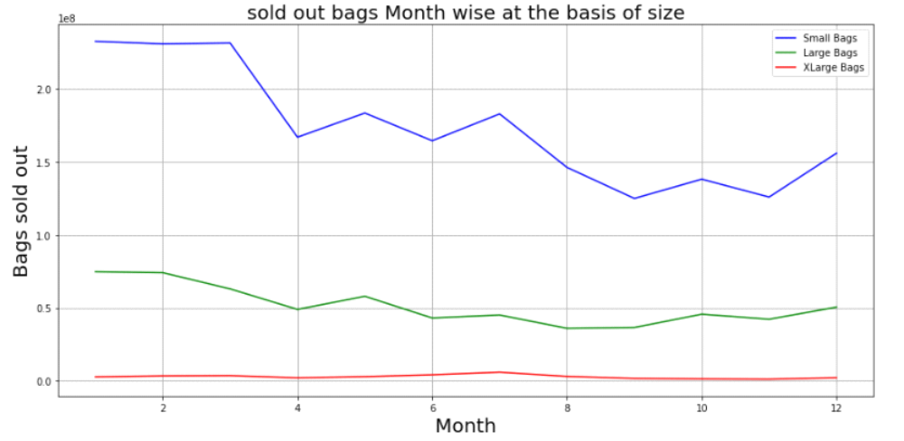
From the above graph it is clear that mostly small bags are used for the avacado so that there selling is high compare to other bags after that second is large bags are used for the avacado. Xlarge bags are less used.
- Removing columns and label encoding- Now we are going towards the model selection so we remove the date column because we created sub columns of this column so we can remove this and region column because it has so many uniques values and we apply label encoding on the column of type because it has only two uniques values.
- dection outliers - Outliers detection: we check the normalization of the dataset and we find that data is not normalized so we move to another step which is for removing the outliers, we use z-score method to remove the outliers. after removing the outliers we use the data which has no outliers.
- One Hot Encoding - we will apply one hot encoding on the type column and after that there will be two sub columns of the type cloumn.
- Model selection- firstly we create input split and after that we split the data in train_test_split.
1. LinearRegression model - we apply this model on our data and get the some results which are mentioned below -
MAE: 0.23297133291654204
MSE: 0.0910880280533739
RMSE: 0.3018079323897467
The RMSE is low so we can say that we do have a good model, but lets check to be more sure. Lets plot the y_test vs the predictions
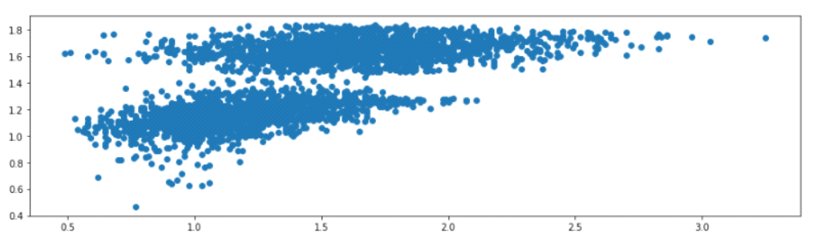
As we can see that we don't have a straight line so I am not sure that this is the best model we can apply on our data Lets try working with the Decision Tree Regression model
2. DecisionTreeRegressor model - we apply this model on our data and get the some results which are mentioned below -
MAE: 0.13752876712328768
MSE: 0.04614575342465753
RMSE: 0.21481562658395578
Very Nice, our RMSE is lower than the previous one we got with Linear Regression.
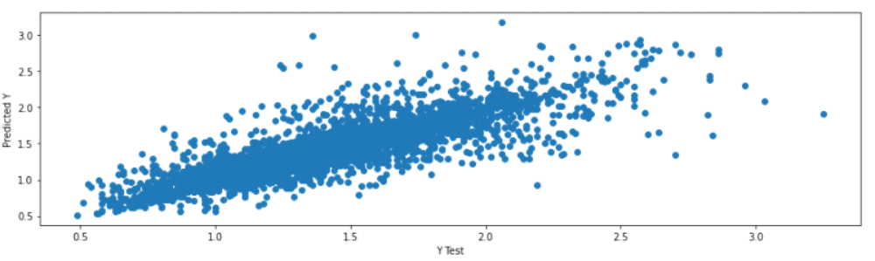
Nice, here we can see that we nearly have a straight line, in other words its better than the Linear regression model
3. RandomForestRegressor model - we apply this model on our data and get the some results which are mentioned below -
MAE: 0.10054241095890408
MSE: 0.021128462093150675
RMSE: 0.14535632801206377
Well as we can see the RMSE is lower than the two previous models, so the RandomForest Regressor is the best model in this case.
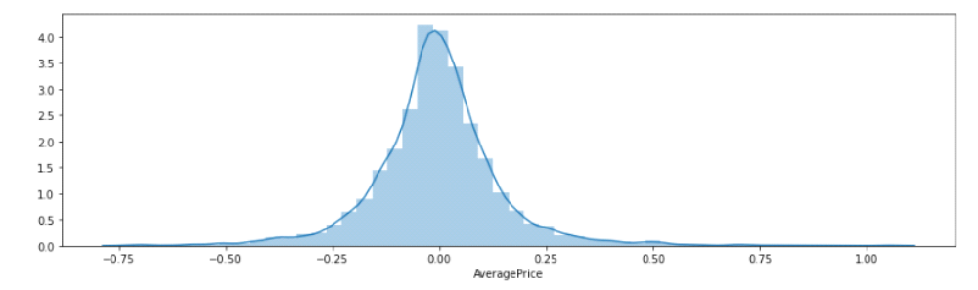
Notice here that our residuals looked to be normally distributed and that's really a good sign which means that our model was a correct choice for the data.
By comparing all above model we can say that RandomForestRegressor model is the best model to predict the data because it has law RMSE valus than the other model.

- Conclusions
1. With the help of notebook I learnt how EDA can be carried out using Pandas and other plotting libraries.
2. Also I have seen making use of packages like matplotlib and seaborn to develop better insights about the data.
3. I have also seen how preproceesing helps in dealing with missing values and irregualities present in the data. I also learnt how to create new features which will in turn help us to better predict the survival.
4. I also make use of pandas profiling feature to generate an html report containing all the information of the various features present in the dataset.
5. I have seen the impact of columns like type, year/date on the Average price increase/decrease rate.
6. The most important inference drawn from all this analysis is, I get to know what are the features on which price is highly positively and negatively coorelated with.
7. I came to know through analysis which model will be work with better accuracy with the help of low residual and RMSE scores.
This project helped me to gain insights and how I should go with flow, which model to choose first and go step by step to attain results with good accuracy. Also get to know where to use Linear, Decision Tree and other applicable and required models to fine tune the predictions.

